STEP ONE: PACER Requirements
To register to practice in the Northern District, you must have an upgraded individual PACER account. If you do not have an upgraded individual PACER account, use the UPGRADING PACER ACCOUNT instructions found HERE.

STEP TWO: Navigating to CM/ECF Registration
Once you have an upgraded PACER account, follow the instructions below to register for CM/ECF access to practice in the Northern District Court.
- Navigate to www.pacer.uscourts.gov
- Click Log in to… at the very top of the page and then click Manage PACER Account.
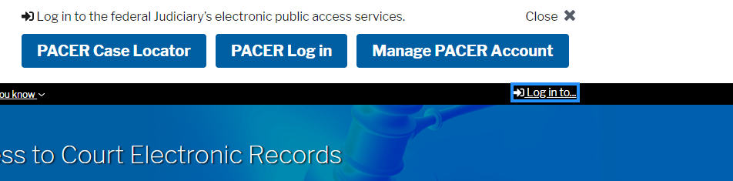

- Login with your upgraded individual PACER account username and password.
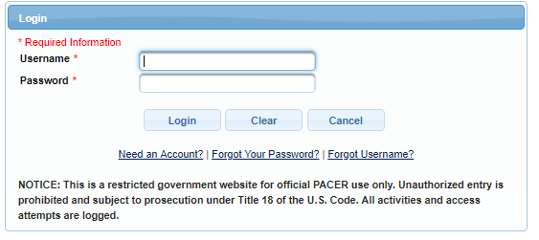

- Click on the Maintenance tab and select Attorney Admission/e-file Registration
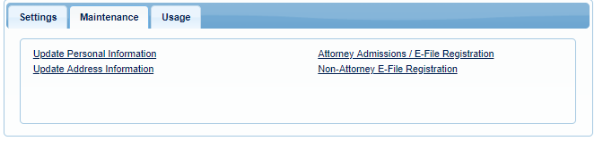
- Select US District Courts then Oklahoma Northern District Court from the drop-down menus and click NEXT
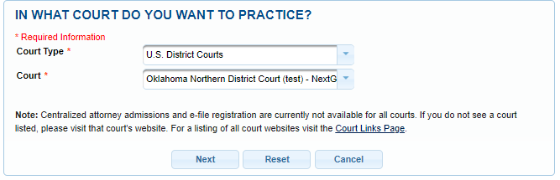

- Select FEDERAL ATTORNEY
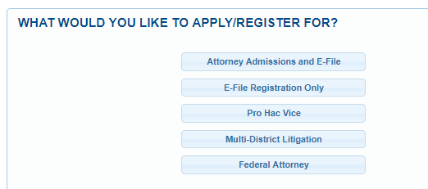

STEP THREE: E-File Registration
Complete the personal information on the E-File Registration Screen. Make sure to specify the Federal Agency in the Firm/Office field or Unit/Department field in the address section and click NEXT. Note that HTML is the preferred Email Format.
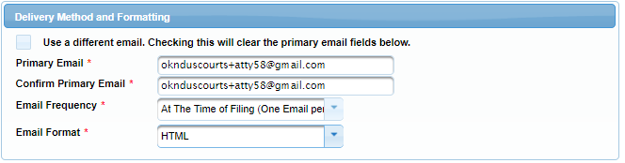

Payment information
Set default payment information, if desired (not required). Click NEXT.
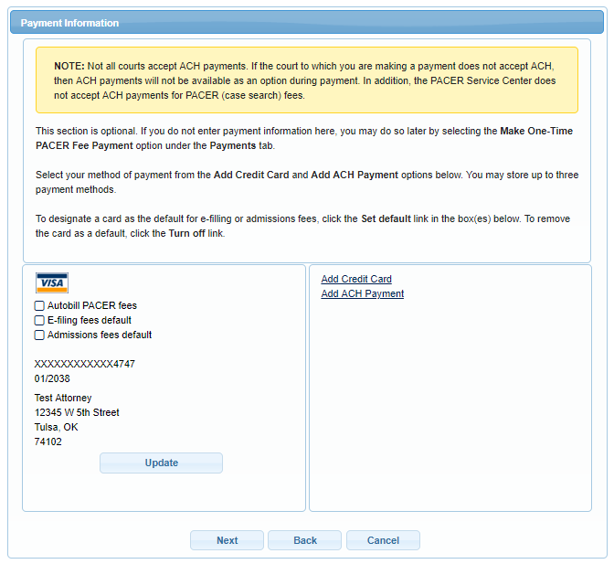

E-Filing Terms of Use
Review the Attorney E-Filing Terms and Conditions and click the boxes acknowledging review and agreement. And click SUBMIT.

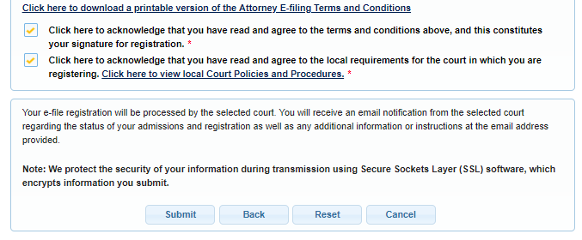

STEP FOUR: AFTER submission
The Court will review your application and, if necessary, will provide you with further instructions through the email address provided. You will be notified via email when the Court has processed your request. NOTE: It may take up to (3) business days for the Court to process your request.

